Analyzing US Geographic Mobility and Median Income to Find Counties and States with Top Sales Growth Potential
Juan Delgado
Syracuse University – IST 652 - School of Information Studies
2024
Table of Contents
Introduction 1
Data Sources 1
Methods of Analysis 2
Code and Process Summary 2
Conclusion 10
Sources Cited 11

Introduction

Coming from a sales background, it is always better to focus business in areas where growth or new business has a higher potential rather than a trial-and-error method. The goal of this analysis is to provide data driven recommendations on geographic areas of opportunity due to population mobility and median income trends. US Census data will be used to perform this analysis with a focus in the following: Mobility by State and County, and Mobility by State and County with Median Income. Once we obtained preliminary results and found counties and states of focus, we used map plot programming to create recommendation maps.
The primary trend we will analyze are people moving to a specific state and county from a different state, due to the post covid trend of high net earners moving to medium or small sized markets for better housing and life opportunities. By finding key counties and states where High Earners are moving into, we can make data driven recommendations of counties and states that are experiencing an influx of income, which makes them areas of business growth potential.

Data Sources

We will use two websites to obtain our data, the Census.gov website and Census Reporter. The Census.gov website gives us the latest available 2023 data, consisting of CSV files. While the Census Reporter website provides data in GeoJSON files that are perfect of map plots. Although the Census Reporter does not have the latest 2023 data, we were able to find 2022 5-year data to analyze previous trends. Then we used pandas merging techniques to apply the geo coding to the latest 2023 Census.gov data.
By using government census data, we remove potential bias and assure we get transparent results. Below are examples of the data we will be using:

- Median Income in the Past 12 Months (In 2023 Inflation-adjusted Dollars) by Geographical Mobility in the Past Year for Current Residence in the United States
  - Need to click on “Geos”, then select “County”, then select “All Counties within the United States and Puerto Rico”
  - When downloading select 2023 ACS 1-year Estimates Detailed Tables
  - https://data.census.gov/table/ACSDT1Y2023.B07011?q=B07011
- Geographical Mobility in the Past Year 2023 for Current Residence--State, County and Place Level in the United States
  - Need to click on “Geos”, then search “County”, then select “All Counties within the United States and Puerto Rico”
  - When downloading select 2023 ACS 1-year Estimates Detailed Tables
  - https://data.census.gov/table/ACSDT1Y2022.B07204?q=geographic
- Median Income in the Past 12 Months (In 2022 Inflation-adjusted Dollars) by Geographical Mobility in the Past 5- Years for Current Residence in the United States
  - Need to click “Download Data” on top right, and select GeoJson file download
  - https://censusreporter.org/data/table/?table=B07011&geo_ids=04000US48,050|04000US48&primary_geo_id=04000US48

Methods of Analysis

For this analysis we are focusing on the mobility of high net earning individuals across state lines. The term mobility is generally defined in the data as people living in a different house 1 year ago. Methods for analyzing this data include the following:
- Using statistics like mean and max values
- Evaluating percent change of median income
- Evaluating the proportions of people that moved into a specific county from another state
- Normalizing values as needed to account for different county and population sizes
Below are questions that used in our analysis:
- Which Counties had the highest percent increase in population from another state?
- Which Counties had the highest influx of high earning people move in from another state?
- What is the median income of people moving into US counties from another state?
- Which counties had the highest median income of people moving in from another state? How does it relate to overall median income in the given county?

Code and Process Summary

Python was the programming language used in this analysis through Google Colab and Jupyter Notebooks on the Anaconda Navigator. First, we needed to install a couple of additional packages to begin our analysis. The Geopandas package is used for creating map plots out of pandas data frames, and the Contextily package is used to add base maps to the map plots. Then we imported both of these packages, as well as the matplotlib, pandas and csv packages. The matplotlib package is used for creating data plots, the pandas package is used to create versatile data frames, and the csv package is used for uploading and using comma separated value (csv) files.
To begin the analysis, we uploaded the Median Income in the Past 12 Months (In 2023 Inflation-adjusted Dollars) by Geographical Mobility in the Past Year for Current Residence in the United States, which will be referred as “GeoMobilityIncome” data. We uploaded this data using an infile and csv reader code method to parse the data into a list of dictionaries. This is my preferred method of uploading csv files because it makes it easy to rename indexes and keeps the data very organized as it is being read and parsed into Python. The result was data from 836 counties was read into a list of dictionaries, then we removed the top 2 rows with column headers, and then transformed it to a pandas data frame for easier analysis.
Once we uploaded this first data set, we noticed some cleanup steps were still necessary to perform math operations. First, we replaced hyphens ‘ – ‘, double stars ‘**’ and triple stars ‘***’ with zeros using .replace() functions, and filled NAs with zeros using the .fillna() function. Then second, we changed all the median income values to numeric. However, certain values had symbols within the cells, so we had to imbed .astype(str) and .str.replace() functions within pd.to_numeric functions to be able to change all values to numeric. This helped us prepare the values to perform a .describe() function on the data frame and find key statistics of each column, we also applied formatting to remove decimals. Below are the results from the .describe() function, which shows us some descriptive statistics on each column. The result rows that stood out the most here were the mean and max columns. First, it is important to understand that ‘median income past 12 months’ includes all the people measured in the other columns, so this column is used more as a baseline of comparison. This means we have two main groups to analyze, people who lived in the same house 1 year ago, and people who did not live in the same house 1 year ago, which means our columns of focus are the latter four columns. Under the ‘mean’ row we see that the ‘median income past 12 months moved from a different state’ column has the highest value of $37,604 and ‘median income past 12 months moved from abroad’ has the lowest value at $23,051, when looking at the latter four columns. Then we see both columns have very high values for the ‘max’ row, showing that ‘moved from a different state’ has a max value of $190,338 and ‘moved from abroad’ has a max value of $250,000. From these observations we can agree that these two groups are of interest in the following phases of our analysis.
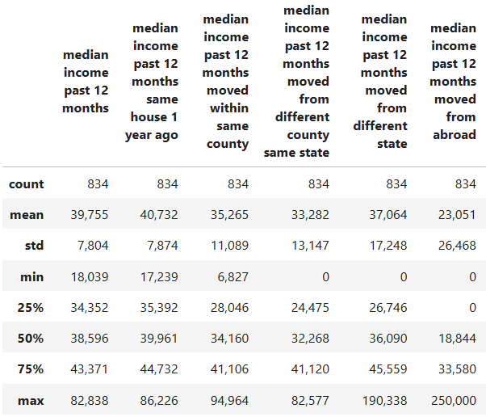

In the next step, we decided to focus on our hypothesized focus group of people that ‘moved from a different state. However, we needed to find a way to normalize our values so that our results did not reflect potential outliers. To do this, we decided to calculate the percent change of ‘median income past 12 months’ which is the total, versus the ‘median income past 12 months moved from a different state. This helps us identify counties with the greatest percentage of median income influx compared to the total median income in the county, instead of just looking at high dollar values which may only identify larger economic cities and areas. This calculation was completed by creating an empty column ‘percent_change_median income out of state’ and inserting the following calculation: ‘percent_change_median income out of state’ = (‘median income past 12 months from different state’ - ‘median income past 12 months’) / ‘median income past 12 months’. We also changed the values to round numbers and switched the type to integers for future calculations. Then we sorted the GeoMobilityIncomeDF by the ‘percent change’ in descending order to see the counties with the highest percent change of median income. To make it easier to see our results, we created a new_GeoMobilityIncomeDF with only the columns 'geo id', 'county name', 'median income past 12 months', 'median income past 12 months moved from different state', and 'percent_change_median income out of state'. In the table below, we see the results of the top 10 counties of opportunity in this step of our analysis.
county name | median income past 12 months | median income  past 12 months  moved from  different state | Percent change  median income  past 12 months vs  moved from different state
Geauga County, Ohio | $43,254 | $190,338 | 340%
Saline County, Arkansas | $40,534 | $115,745 | 186%
Walton County, Georgia | $36,318 | $100,617 | 177%
Hamblen County, Tennessee | $32,126 | $85,101 | 165%
Madera County, California | $30,331 | $79,201 | 161%
Pender County, North Carolina | $37,663 | $93,269 | 148%
Smith County, Texas | $33,099 | $76,591 | 131%
Warren County, New York | $41,632 | $95,408 | 129%
Morgan County, Alabama | $36,365 | $82,828 | 128%
St. Francois County, Missouri | $29,562 | $65,455 | 121%

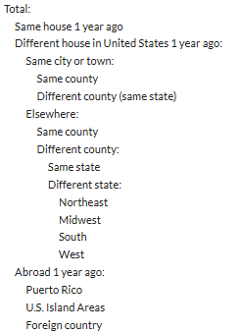
In the next part of this analysis, we looked at the quantities of people moving into counties from another state to provide another dimension to our business opportunity recommendations. We are unable to base our analysis on median income alone, in case there are scenarios where a small amount of high earning people moved into a given county. To do so, we uploaded the Geographical Mobility in the Past Year 2023 for Current Residence--State, County and Place Level in the United States, which will be reference as “GeoMobility” data. (Please note the overall steps in this phase of the analysis are very similar to the first part of the analysis.) We uploaded this data again using an infile and csv reader code method to parse the data into a list of dictionaries. This time we noticed many rows with null values, so we added an if else statement in the reader to skip lines that started with ‘null’ in column index 6. The result was data from 609 counties was read into a list of dictionaries, which meant about 200 counties without data were being potentially omitted from the first part of our analysis. Then we removed the top 2 rows with column headers, and then transformed it to a pandas data frame for easier analysis.
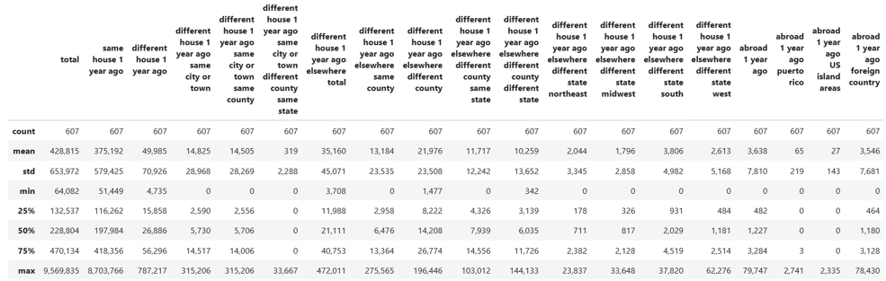
Once we uploaded this second data set it was already very cleaned up. We just had to change all the values to numeric, which was much easier this time as no symbols were in any of the rows. We simply used pd.to_numeric functions on each column. Then we performed another .describer() function on the data frame to find key statistics of each column, and also applied formatting to remove decimals. Below are the results from the .describe function, which shows us some descriptive statistics on each column. The result rows that stood out the most here were again the mean and max rows. First, it’s important to understand that this data follows the hierarchy in the image to the right, where indentations add up to the appropriate un-indented row. For example, ‘Total’ is equal to people that were in the ‘Same house 1 year ago’, plus the people that lived in a ‘Different house in the United States 1 year ago’, plus people that lived ‘Abroad 1 year ago’. Since we are focusing on people that lived in a different state, we will focus on three columns: ‘different house 1 year ago elsewhere total’ this is the total number of people that lived elsewhere and is our baseline, ‘different house 1 year ago elsewhere same county’ this is people that lived in the same county name in a different state, and ‘different house 1 year ago elsewhere different county different state’ these are people that lived in a different county in a different state altogether. Under the ‘mean’ row we see that the ‘different house 1 year ago elsewhere total’ column has a value of 35,160 and ‘abroad 1 year ago’ has a value of 3,638. Seeing that ‘elsewhere total’ has a higher mean of about 30k to ‘abroad total’ validates our decision to focus primarily on our hypothesized group of people that moved from a different state. This trend is further validated on the ‘max’ row, where ‘elsewhere total’ has a max value of 472,011 and ‘abroad total’ has a max value of 79,747. Although both groups had comparably high median income values for the ‘max’ row in the GeoMobilityIncome phase of our analysis (‘moved from a different state’ max value of $190,338 and ‘moved from abroad’ max value of $250,000), the GeoMobility data shows that a much smaller amount of people are moving to counties from abroad compared to from a different state. From these observations we can agree and validate that high earners moving from a different state are the key group that we should focus on to identify key areas of business opportunity.

Next, we added a new column to the GeoMobilityDF called ‘lived out of state’ and we added together the values from columns ‘different house 1 year ago elsewhere same county’ and ‘different house 1 year ago elsewhere different county different state’. Making this new column made it easier for us to visualize and perform operations on the total amount of people that ‘lived out of state’. Since some counties may have a very large population due to having a large city or metro area, we also needed to normalize our ‘lived out of state’ column to make concrete analysis and recommendations. We created an empty column for ‘normalized_lived out of state’, and then placed our calculation in the column by dividing the people the people that ‘lived out of state’ by the total number of people that lived in a ‘different house 1 year ago elsewhere total’. Once this calculation was done, we sorted the GeoMobilityDF by the ‘normalized_lived out of state’ column in descending order, which gave us a new list of results. However, since these results only account for mobility and not income, we needed to merge our GeoMobilityIncomeDF and GeoMobilityDF. To prepare for this next step, we created a new_GeoMobilityDF with the columns 'geo id', 'county name', 'different house 1 year ago elsewhere total', 'lived out of state', 'normalized_lived out of state'. By using a pd.merge() function we performed an inner join on the ‘geo id’ columns for our new_GeoMobilityIncomeDF and new_GeoMobilityDF. With our new merged_df, we performed a 2-tier sorting on the data frame in descending order. First, we sorted by the ‘percent_change_median income out of state’, then second by the ‘normalized_lived out of state’ column. We performed the 2-tier sort in this order since median income is the main driver of the analysis, with normalized population results validating our results. Below is a table with the final recommendations of counties with high potential for business growth. Since some counties were omitted due to data availability for the GeoMobilityDF, any of the top 10 counties in the first table should also be considered as high growth potential counties.
county name | total lived  in different house  US elsewhere | lived out of state | normalized  lived out of state | median income  past 12 months | median income  past 12 months  moved from different state | percent change  median income  out of state
Saline County, Arkansas | 9810 | 5182 | 53% | $40,534 | $115,745 | 186%
Smith County, Texas | 20320 | 12089 | 59% | $33,099 | $76,591 | 131%
Forsyth County, Georgia | 22152 | 13644 | 62% | $56,566 | $122,620 | 117%
Glynn County, Georgia | 10348 | 8020 | 78% | $38,090 | $80,191 | 111%
Bedford County, Virginia | 9138 | 4809 | 53% | $37,922 | $78,985 | 108%
El Dorado County, California | 18991 | 10355 | 55% | $51,125 | $101,977 | 99%
Bradley County, Tennessee | 13467 | 10039 | 75% | $32,057 | $63,224 | 97%
Plymouth County, Massachusetts | 36260 | 19248 | 53% | $48,568 | $93,241 | 92%
Baldwin County, Alabama | 20727 | 14722 | 71% | $38,135 | $72,857 | 91%
Deschutes County, Oregon | 16985 | 10923 | 64% | $46,487 | $87,421 | 88%

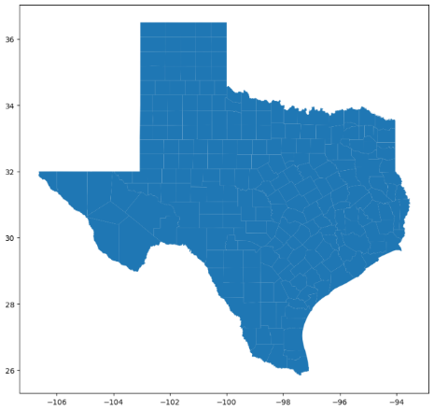
For the next phase of our analysis, we wanted to analyze our mobility and income trends results and visualize them on intuitive maps. As an example, we used the state of Texas for the business growth potential maps, with the goal to provide them to business development teams. Here is where we will use the geopandas and contextily packages. Please note, that we had performed this analysis on two separate Jupyter notebooks, so we re-uploaded all files for this section of the analysis. First, we uploaded the Texas GeoJSON file as ‘gdf’ using the geopandas .read_file() function, the ‘gdf’ will be referred to as ‘GeoDataFrame’ going forward. Then we looked at the shape of our GeoDataFrame using gdf.shape and found 237 row or counties and 15 columns were read and parsed. Our GeoDataFrame also had a few leading rows, so we removed the first 3 rows using gdf.drop() with an imbedded range of (0,3). This GeoDataFrame has all the same columns from the GeoMobilityIncomeDF, along with an extra column called ‘geometry’ which has the latitude and longitude boundaries of each county for mapping. By using gdf.plot(figsize=(10,10)) we were able to get a preliminary view of our ‘geometry’ boundaries and verified that they were working appropriately, see image to the right of the plot. Then, by using gdf.sample().plot() we verified the individual counties were mapping correctly individually. Now that we verified the boundaries were working, we needed to select and rename the columns for our analysis. By using gdf.info() we were able to see the different file types and columns available, ‘geoid’ and ‘name’ were object strings, the ‘B07011001’ to ‘B07011006’ columns were float numeric, and the ‘geometry’ column was geometry type as latitude and longitude coordinates. The columns we need to rework here are the ‘B07011001’ to ‘B07011006’, the float type is ready for operations, but we did not know the corresponding column names. To do this, we reviewed the metadata from the Census Reporter data download and picked which columns to keep by creating a list ‘columns_to_keep’, then using the code gdf = gdf[columns_to_keep]. Then we renamed the columns with gdf.columns and making it equal to a list of column names, ['geoid', 'name', 'median income past 12 months', 'same house 1 year ago', 'moved within same county', 'moved from a different county within the same state', 'moved from a different state', 'moved from abroad', 'geometry']. By printing the GeoDataFrame we also noticed many cells had null values, so we used gdf.fillna(0) to fill these values with zeros. This wrapped up the cleaning and renaming of our GeoDataFrame.
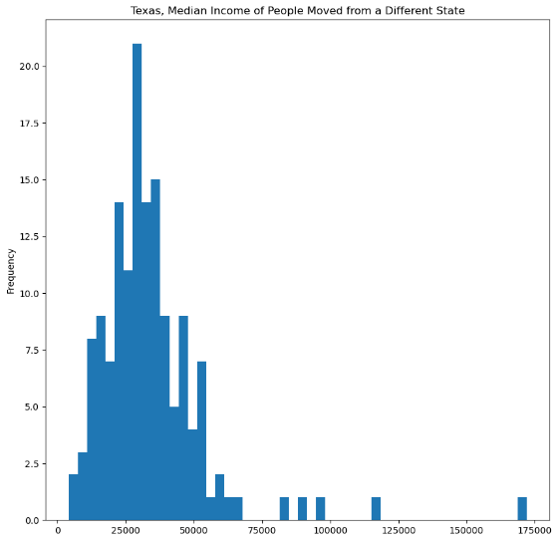
Now that we had a clean data frame, we moved forward with creating intuitive mapping for our business growth potential recommendations. Please note that the data in the following maps is 2022 5-year data instead of 2023 data used in the first phases of the analysis. First, to get an idea of median income in Texas with our new data, we plotted a histogram focusing on people that ‘moved from a different state’, see image on the right. We did this using gdf[‘moved from a different state’].plot.hist() and adjusted the chart to be 10 x 10 with 50 bins and a title. Below is an image of the histogram generated. In the histogram we see a right-skewed curve where the bulk of the counties fall below ~$70,000, and a few counties fall on the higher end with median income above $75,000. From this data distribution, we can conclude that the counties above $75,000 are the biggest potential areas for growth. From here we wanted to plot our data on maps to show our results in a more intuitive manner. To do so, we used the same gdf.plot(figsize=(10,10)), but this time we added 3 more arguments, we specified the following: column = ‘moved from a different state’, the color cmap=’plasma’, and a legend with legend=True. The resulting map is below to the left, with the yellow and orange hued counties being the ones with median income above $75,000. Now that we have identified the counties with the highest median income for people who ‘moved from a different state’, we wanted to take it one step further by placing a base map in our plot, this basemap is very similar to the maps used on google maps showing states, cities, towns, roads and boundaries. To do so, first we need to convert our GeoDataFrame to a web Mercator projection, which is used for most web mapping services. The web Mercator projection is identified by the ESPG code 3857, and it uses a projected coordinate system with units in meters, and the coordinates represent distances from the Equator and Prime Meridian. By converting to a web Mercator, the contextily package provides tiled basemaps from online sources to overlay your own geospatial data correctly on these basemaps. For our GeoDataFrame we simply used gdf.to_crs(epsg=3857) to convert to our gdf_web_mercator, which will be referred to as GeoDataFrameWebMercator. Now we create a plot to show counties with greater than $75,000 median income for people ‘moved from a different state’, which is the image below to the right. For this code, first we define the type and size of the plot with fig, ax = plt.subplots(figsize=(10,10)). Then we define the GeoDataFrameWebMercator as the source, the ‘moved from a different state’ as the data column with > 75000, and defined the overlay plot with .plot(ax=ax, alpha=0.8), alpha is used to make the plot points more transparent. We turn off the axis with ax.axis() to not distort the data boundaries in reference to the base map, and set a title with ax.set_title(), and finally defined and added the basemap with contextily using ctx.add_basemap(ax). The final products are below and show intuitive maps that clearly show the top counties with potential growth opportunity.
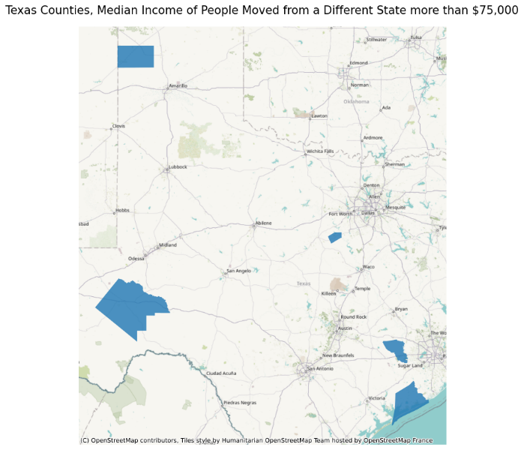
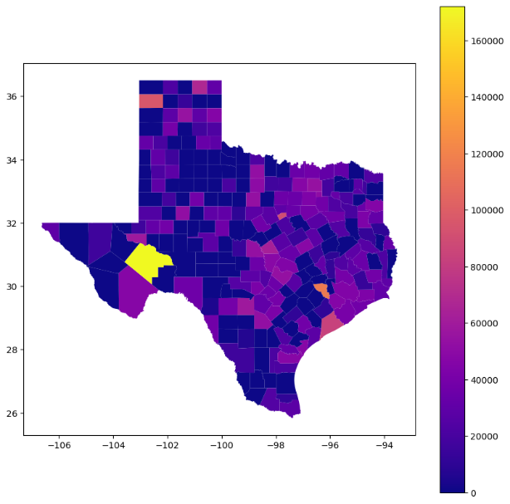

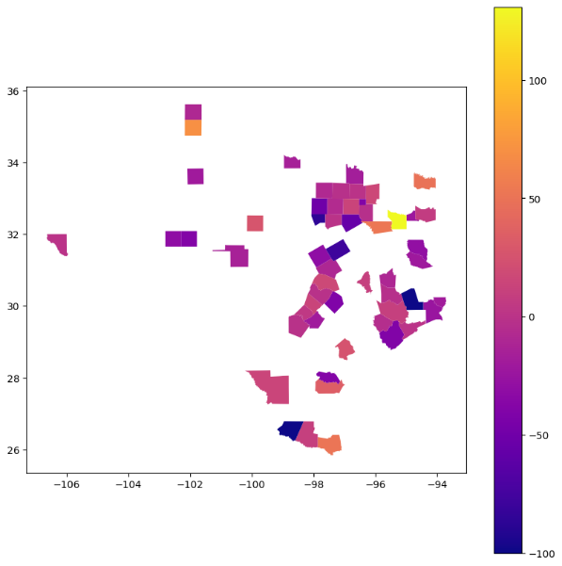
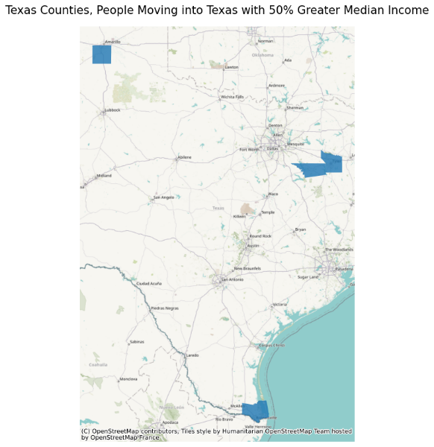
Upon further analyzing the data for the Texas counties above, we realized that the median income trends for people who ‘moved from a different state’ did not align with the trends discovered in the first phase of our analysis. This was likely due to the Texas maps data is 5-year median income data from 2022, and in the first phases of the analysis the data is the latest available from 2023. Due to the difference in trends, for the next phase of our analysis we decided to take the 2023 data and merge in the latitude and longitude coordinates from the 2022 Census Reporter data. First, we uploaded a condensed version of the GeoMobilityIncomeDF using the csv infile and reader method into a list of dictionaries, with the columns ‘geoid’, ‘county name’ and ‘percent_change_median income out of state’, then created a pandas data frame called ResultsDF. With some web searches, we learned that pandas and geopandas data frames were compatible, which made the merging of the files possible. Then we took our GeoDataFrame and made a new condensed geopandas dataframe with the columns ‘geoid’, ‘geometry’ and ‘county name’. This was done with a previous technique, where we created a list of ‘columns_to_keep2’ and then placed them in a new dataframe, gdf2 = gdf[columns_to_keep2] and will be referred to as GeoDataFrame2. We also converted the ‘geoid’ column to string type to avoid merge errors. However, merge errors continued happening and we realized the ‘geoid’ columns did not match. The ‘geoid’ for the ResultsDF had additional zeros, so we defined our desired string to change as string = ‘05000’ and used a .replace() function to change all the ‘geoid’ values to match, ResultsDF['geoid'] = ResultsDF['geoid'].str.replace(r'^.{7}', string, regex=True). This code kept the seven string characters on the right and replaced the rest with ‘05000’, which effectively removed the unwanted zeros and resulted in a successful merge of the data frames. We performed an inner join with on the data frames with the .merge() function on the ‘geoid’ column, then we changed the type of the ‘percent_change_median income out of state’ to float data type to make sure it populated in the map plots to follow. For the map plots we used the same code and process as the previous Texas plots and obtained the results below. The key difference with the maps below were that far fewer counties had data reported, and this time we used the ‘percent_change_median income out of state’ instead of the median income ‘moved from a different state’. On the color-coded map below to the right, we see that the yellow and orange hue counties are those above 50%, so we decided to use this as our benchmark for the map below to the right. The highlighted counties in blue are those where people who are moving in from out of state have 50% or more the income compared to the total median income in that same county. Therefore, these are the counties with highest growth opportunity potential in the state of Texas. To provide further and more focused areas, we also imported the results from the ‘percent_change_median income out of state’ along with the ‘normalized_lived out of state’ based on the quantities of people who moved from another state, this data frame was defined as ResultsDF2. For these maps we followed the same process as we did for the maps above and produced the maps below. As you can see, the maps are very similar just with less counties highlighted. These maps accurately pinpoint the Texas counties with people moving from a different state with 50% greater median income than the median income for the county, while accounting for the amount of people are actually moving into the county, meaning that they have a high influx of high earning people moving into those counties. Our final map results below, are the most accurate recommendations for Texas counties with high potential for business growth.
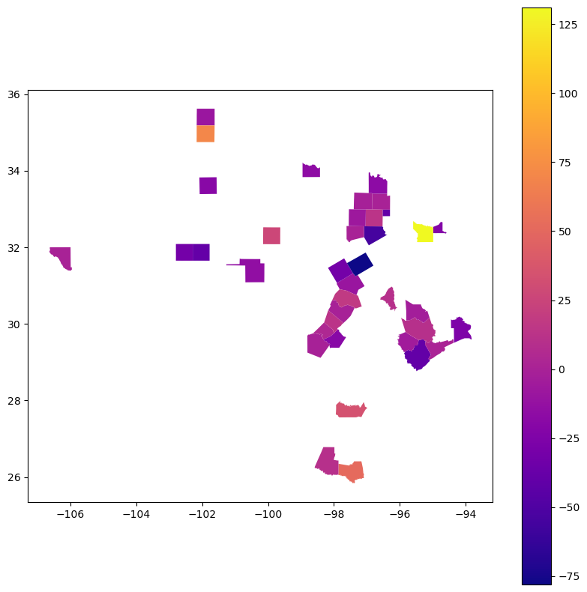
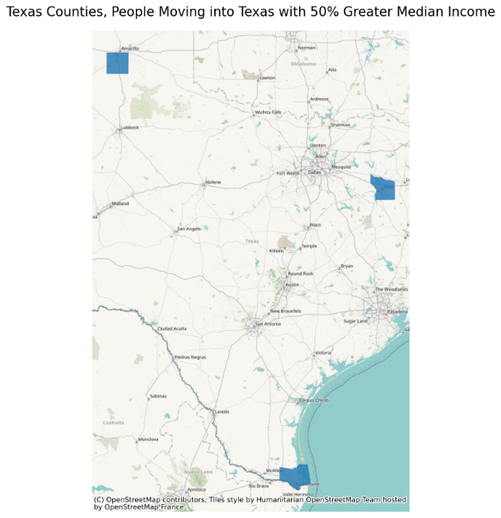

Conclusion
Census data helped us accurately find top counties of business growth opportunity in the United States, as well and mapping out intuitive maps that can be easily shared with business development teams. We are also confident Census data gives unbiased, transparent, and generally accurate results. Although the data may not always be complete for the most recent years, it is a strong representation of the mobility of high earning individuals in the United States. Texas was used as an example for geo mapping our data, and these techniques can be replicated for other states, counties or areas of interest.

Sources Cited

U.S. Census Bureau. "Geographical Mobility in the Past Year for Current Residence--State, County and Place Level in the United States." American Community Survey, ACS 1-Year Estimates Detailed Tables, Table B07204, 2022, https://data.census.gov/table/ACSDT1Y2022.B07204?q=geographic&g=010XX00US$0500000. Accessed on December 11, 2024.

U.S. Census Bureau, U.S. Department of Commerce. "Median Income in the Past 12 Months (in 2023 Inflation-Adjusted Dollars) by Geographical Mobility in the Past Year for Current Residence in the United States." American Community Survey, ACS 1-Year Estimates Detailed Tables, Table B07011, 2023, https://data.census.gov/table/ACSDT1Y2023.B07011?q=B07011: Median Income in the Past 12 Months (in 2023 Inflation-Adjusted Dollars) by Geographical Mobility in the Past Year for Current Residence in the United States. Accessed on December 11, 2024.

U.S. Census Bureau (2018-2022). Median Income in the Past 12 Months (In 2022 Inflation-adjusted Dollars) by Geographical Mobility in the Past Year for Current Residence in the United States American Community Survey 5-year estimates. Retrieved from <https://censusreporter.org>

